Production Planning and Execution (PP) Case Study

Step 1: Change Material Master Record

Submit the screen shot showing the historic consumption values for the black bike (2.5 points)

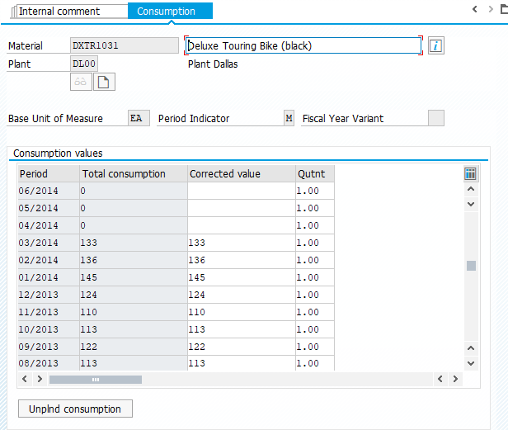

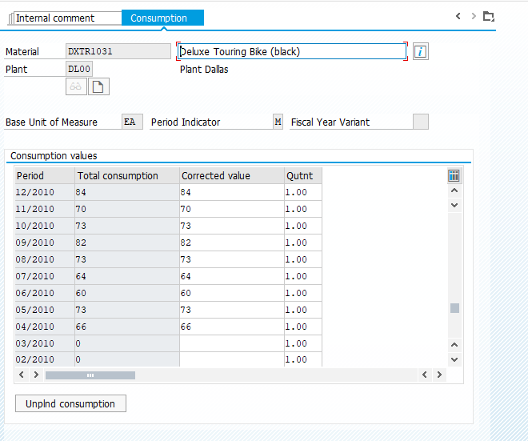

Step 2: Change Routing

Submit the screen shot showing the Item Overview Screen (2.5 points)

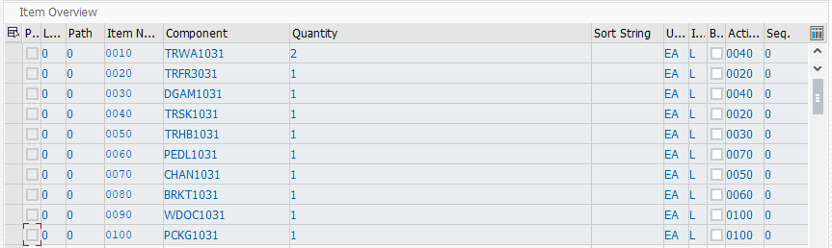

Step 3: Display Product Group

Submit the screen shot showing the Display Product Group: Members (Materials) (2.5 points)

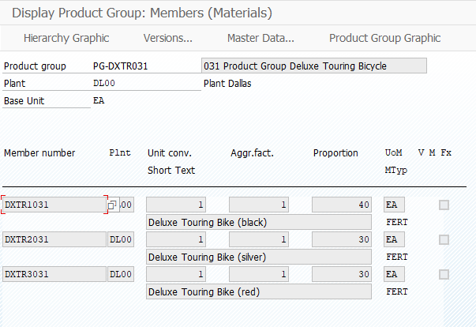

Step 4: Create Sales and Operations Plan

Submit the screen shot showing the Forecast: Results (2.5 points)

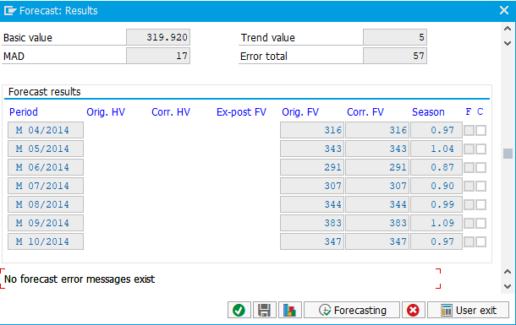

Submit the screen shot showing the Change Rough-Cut Plan(2.5 points)

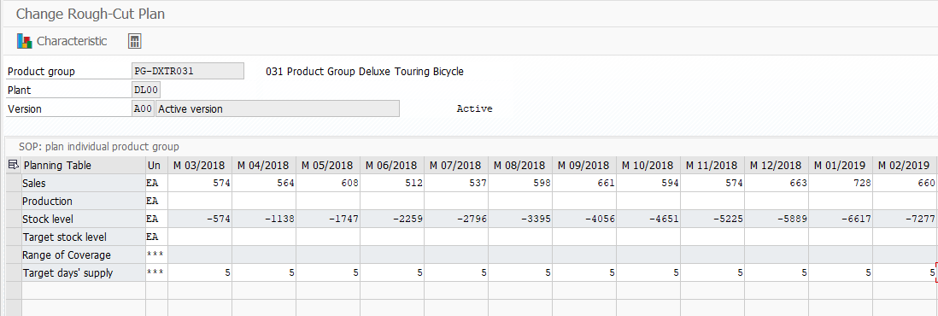

Submit the screen shot of the graph of the planning (2.5 points)

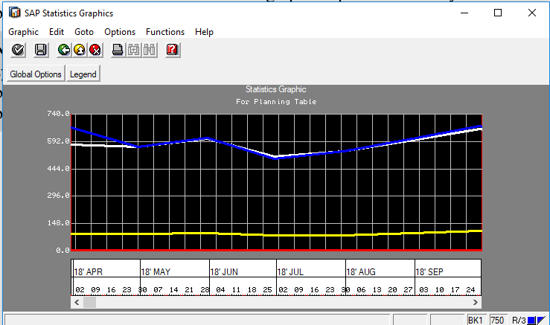

Step 5: Transfer SOP to Demand Management

Submit the screen shot showing the Planned Independent Requirement for DXTR1XXX (2.5 points)

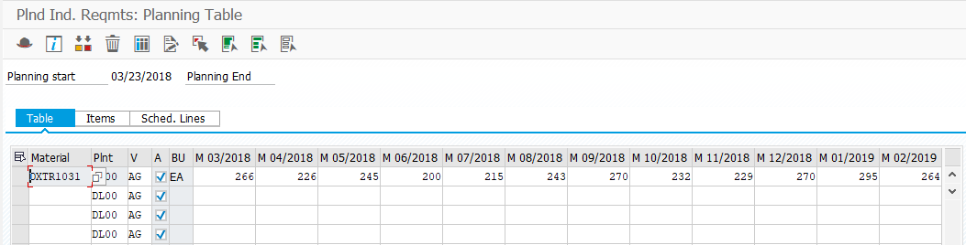

Submit the screen shot showing the Planned Independent Requirement for DXTR2XXX (2.5 points)

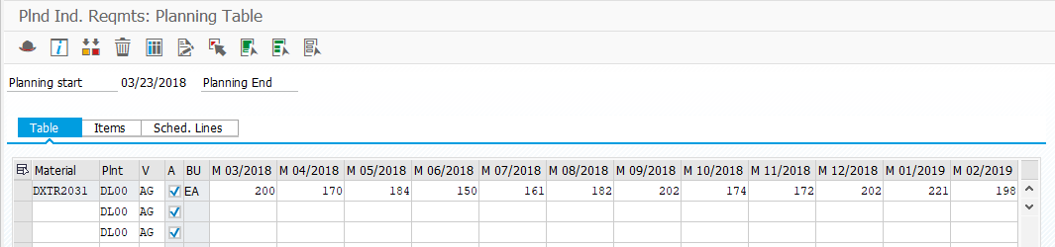

Submit the screen shot showing the Planned Independent Requirement for DXTR3XXX (2.5 points)

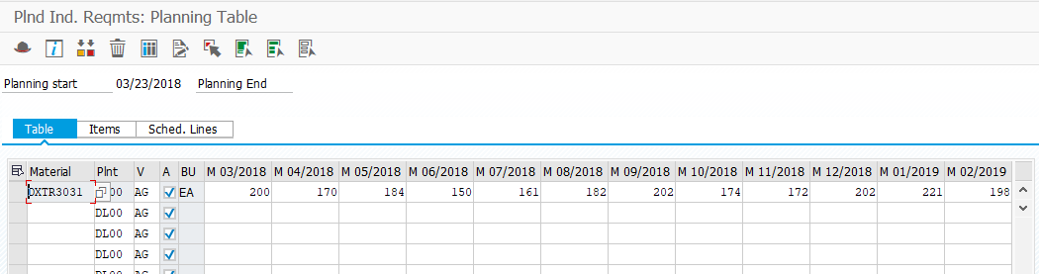

Step 6: Review Demand Management

Submit the screen shot showing the Planned Independent Requirements (2.5 points)

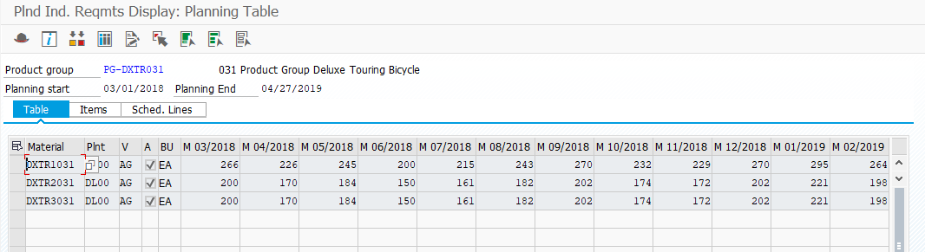

Submit the screen shot showing the scheduled lines tab screen for DXTR1XXX (2.5 points)

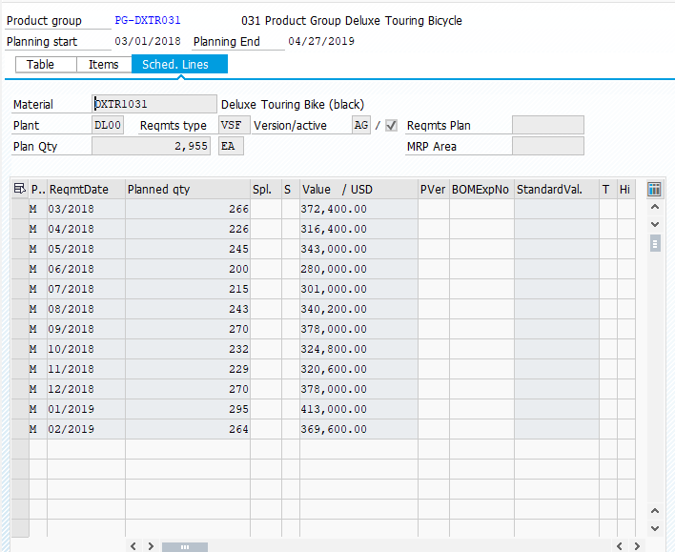

Submit the screen shot showing the scheduled lines tab screen for DXTR2XXX (2.5 points)

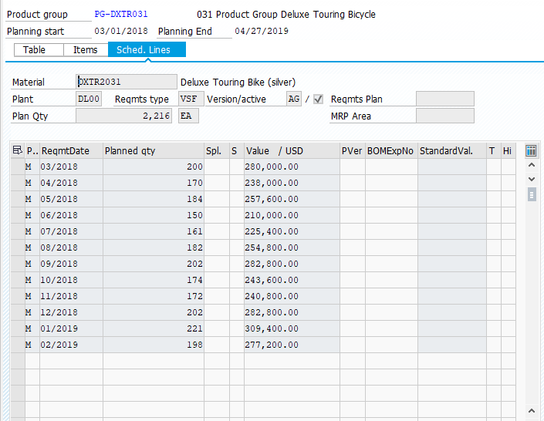

Submit the screen shot showing the scheduled lines tab screen for DXTR3XXX (2.5 points)

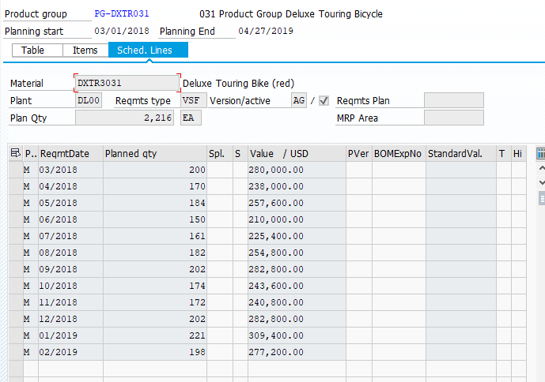

Step 7: Run MPS with MRP

Submit the screen shot showing the list display (2.5 points)

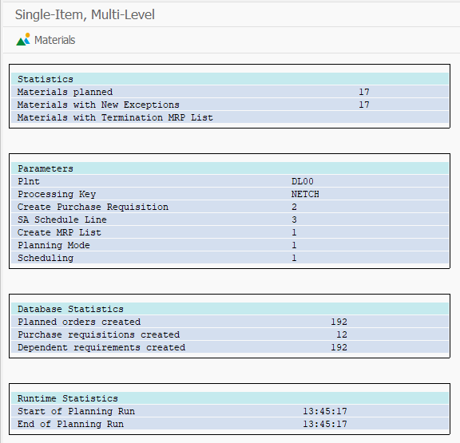

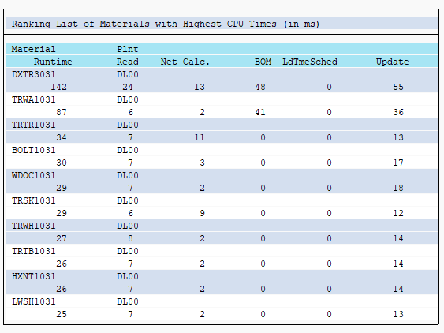

Step 8: Review Stock/Requirements List

Submit the screen shot showing the Stock/Requirements List for DXTR3XXX(2.5 points)

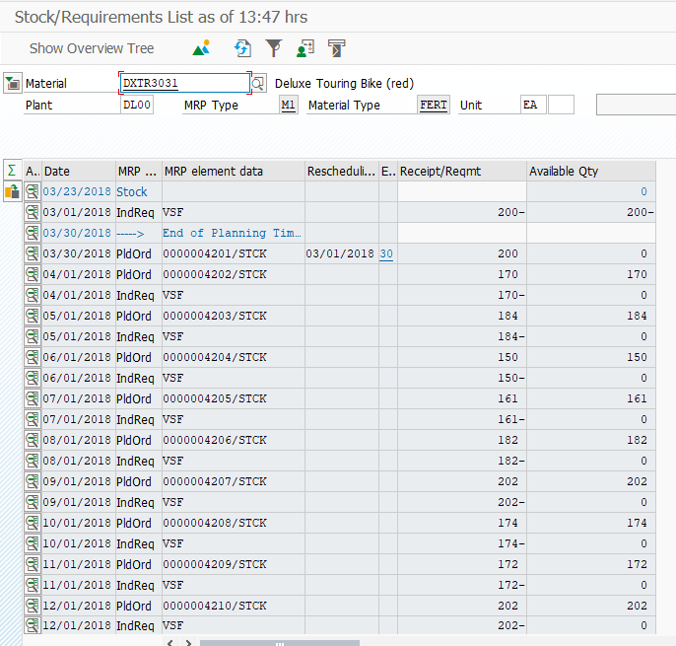

Submit the screen shot showing the Pegged Requirements screen for DXTR3XXX (2.5 points)

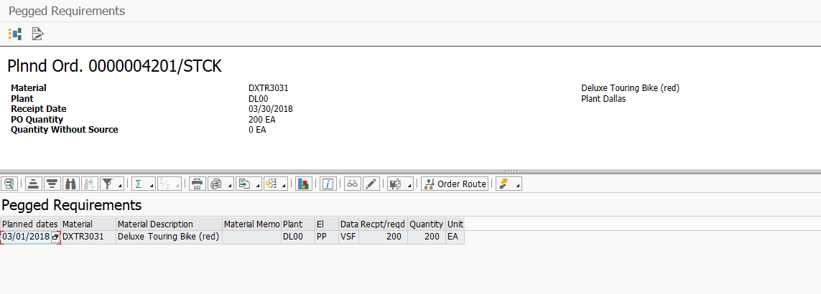

Step 9: Convert Planned Order into Production Order

Submit the screen shot showing Production order Create: Header screen (2.5 points)

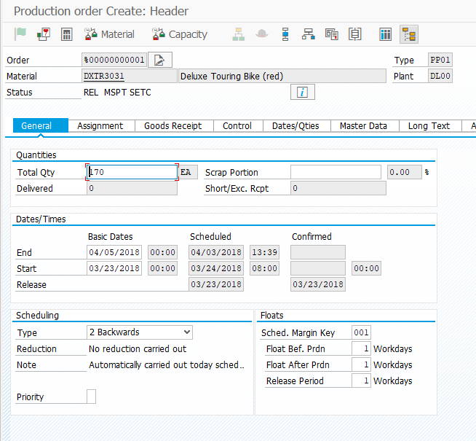

Submit the screen shot showing the Stock/requirements (2.5 points)

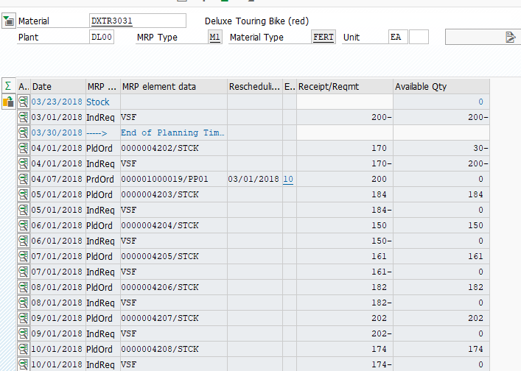

Step 10: Receive Goods in Inventory

Submit the screen shot showing the Items Screen (2.5 points)

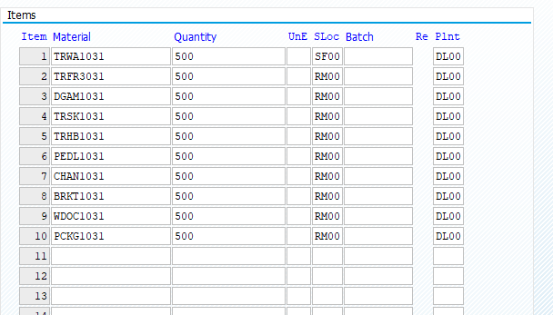

Step 11: Issue Goods to Production Order

Submit the screen shot showing the Items Screen (2.5 points)

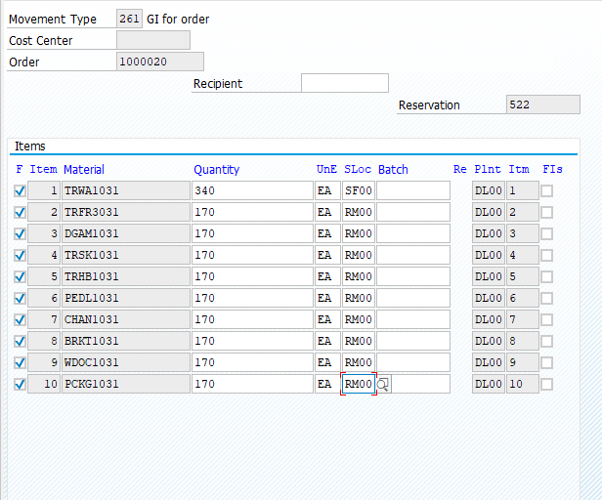

Submit the screen shot showing the Enter Goods Issue: Overview (2.5 points)

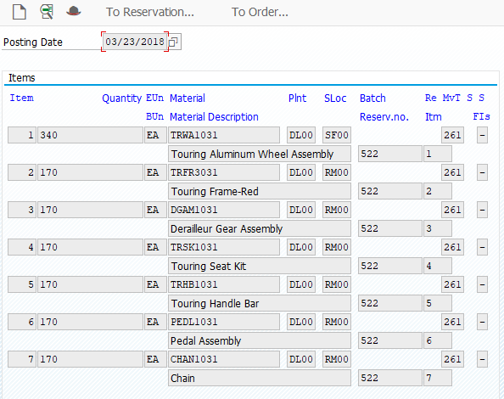

Step 12: Review Production Order Status

Submit the screen shot showing the Display Status screen(2.5 points)

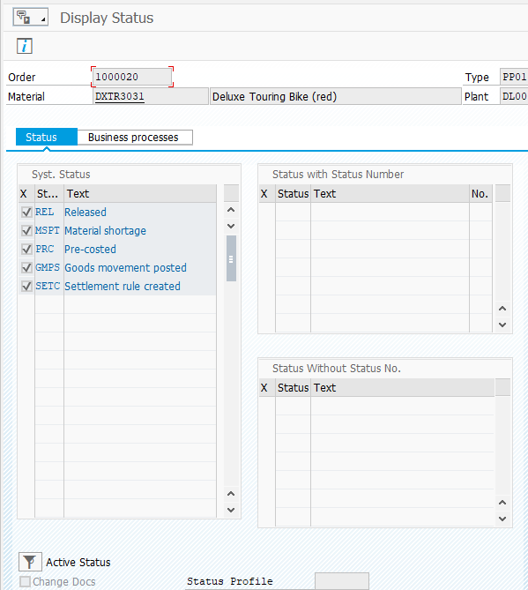

Submit the screen shot showing the costs assigned to the production order(2.5 points)

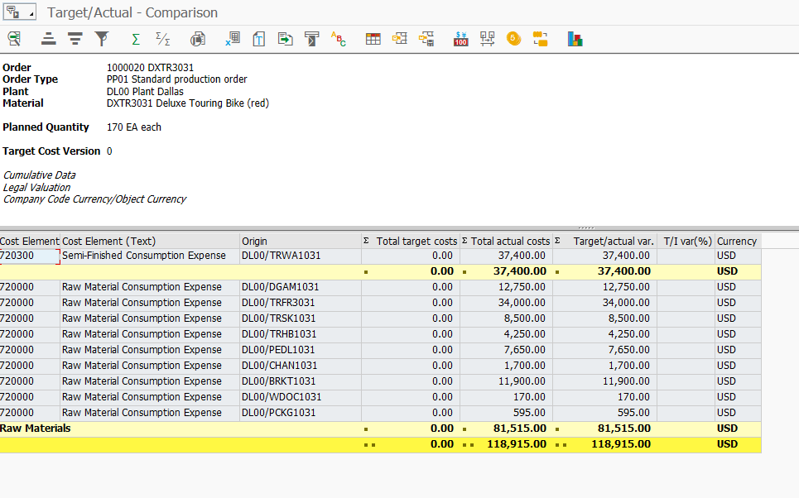

Step 13: Confirm Production Completion

No screenshot required.

Step 14: Receive Goods from Production Order

Submit the screen shot showing the Goods Receipt for Order: Overview 0001/0001 (2.5 points)

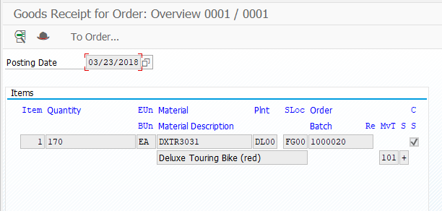

Step 15: Review Costs Assigned to Production Order

Submit the screen shot showing the cost assigned to production order(2.5 points)

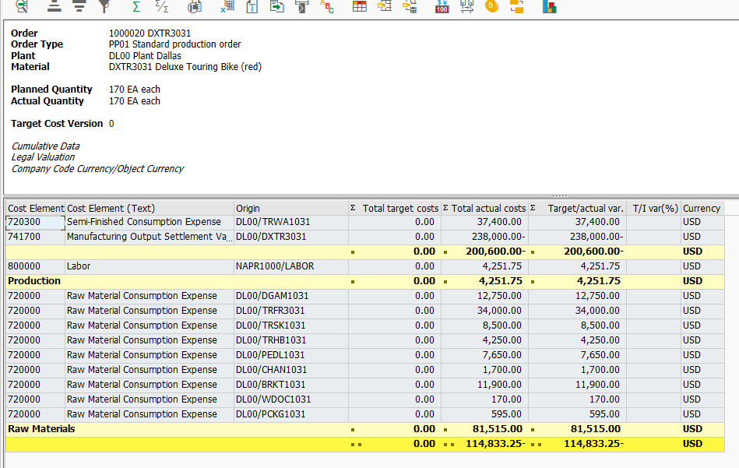

Step 16: Settle Costs of Production Order

Submit the screen shot showing the Orders: Actaul/Plan/Variance(2.5 points)

